Supplementary 1
Accession Numbers
strain 1AJ1: MG062799, strain 1AJ2: MG062800, strain 1AJ3: MG062801, strain 1AJ4: MG062802, strain 1BJ1: MG062803, strain 1BJ2: MG062804, strain 1BJ3: MG062805, strain 1BJ4: MG062806, strain 1BJ6: MG062808, strain 1BJ7: MG062809, strain 1BJ8: MG062810, strain 1BJ9: MG062811, strain 1CJ1: MG062812, strain 1CJ2: MG062813, strain 1CJ3: MG062814, strain 1CJ4: MG062815, strain 1CJ5: MG062816, strain 1CJ6: MG062817, strain 1CJ7: MG062818, strain 1CY1: MG062819, strain 1EJ1: MG062820, strain 1EJ4: MG062821, strain 1EJ6: MG062823, strain 1EJ7: MG062824, strain 1EY1: MG062825, strain 1EY8: MG062826, strain 3AJ1: MG062827, strain 3AJ4: MG062828, strain 3AJ5: MG062829, strain 3AJ7: MG062830, strain 3BJ2: MG062831, strain 3BJ3: MG062832, strain 3BJ4: MG062833, strain 3BJ5: MG062834, strain 3BJ6: MG062835, strain 3BJ7: MG062836, strain 3BJ8: MG062837, strain 3BJ9: MG062838, strain 3CJ6: MG062839, strain 3CJ8: MG062840, strain 3CJ9: MG062841, strain 3DJ1: MG062842, strain 3DJ2: MG062843, strain 3DJ6: MG062844, strain 3EJ1: MG062845, strain 3EJ2: MG062846, strain 3EJ3: MG062847, strain 3EJ4: MG062848, strain 3EJ5: MG062849, strain 3EJ6: MG062850, strain 3EJ7: MG062851, strain 3EJ8: MG062852, strain 3EY1: MG062853, strain 3EY3: MG062854, strain 3EY4: MG062855

Supplementary 2

Fig.S2 Reducing sugar production and enzyme activities in CMC-Na (a) and Avicel (b) as sole carbon source medium.
Supplementary 3
Recombined enzyme activity
Bgl
Table S3-1 p-NP standard curve
p-NP(mM) | 0.025 | 0.050 | 0.075 | 0.100 | 0.125 | 0.150 | 0.175 | 0.200 | 0.225
OD410 | 0.190 | 0.336 | 0.463 | 0.604 | 0.731 | 0.878 | 1.003 | 1.117 | 1.259
Y=5.3153X+0.0668 R²=0.999
Measured method:
5μL crude enzyme + 20μL 25mM p-NPG + 115μL PBS →50℃, 10min→70μL 0.4M Na2CO3→OD410
Table S3-2 Bgl enzyme activity
Blank | OD410 | U/mL | U_{average}/mL | SD
0.139 | 0.645 | 1652.588 | 1670.147 | 18.93862
0.142 | 0.652 | 1667.639 | 1670.147 | 18.93862
0.142 | 0.658 | 1690.215 | 1670.147 | 18.93862

Egl
Table S3-3 Glucose standard curve
Glucose content(mg) | 0.000 | 0.010 | 0.020 | 0.030 | 0.040 | 0.050 | 0.060 | 0.070 | 0.080
OD540 | 0.109 | 0.131 | 0.316 | 0.519 | 0.725 | 0.906 | 1.142 | 1.323 | 1.544
Y=20.21X-0.0837 R²=0.999
Measured method:
50μL crude enzyme + 50μL PBS +100μL 1%CMC-Na substance→50℃,30min→300μLDNS→100℃,5min→OD540
Table S3-4 Egl enzyme activity
Blank | OD540 | U/mL | Uaverage/mL | SD
0.112 | 0.754 | 0.132845 | 0.130343 | 0.002318
0.115 | 0.732 | 0.128268 | 0.130343 | 0.002318
0.113 | 0.739 | 0.129916 | 0.130343 | 0.002318

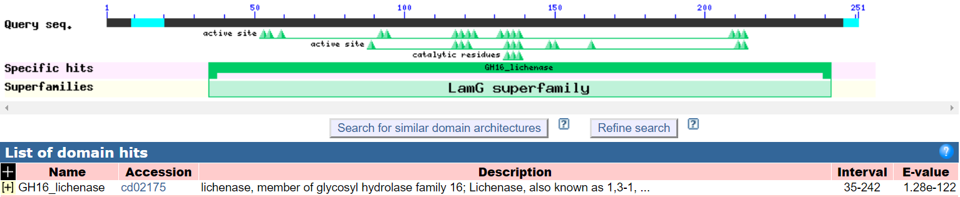
Supplementary 4

Figure S4 Domain analysis of Bgl

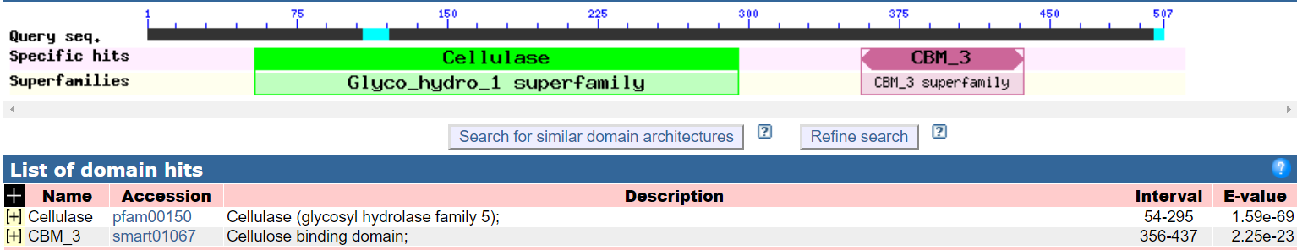
Supplementary 5

Figure S5 Domain analysis of Egl

